

*IdentityIQ Accelerator Pack Create Edit Register*

Table of Contents

1. Overview 3

2. Create Identity Process 3

3. Edit Identity Process 3

4. Register Identity Process 3

**Document Revision History**

|  |  |  |  |  |
| --- | --- | --- | --- | --- |
| **Version** | **Date** | **Status** | **Author** | **Summary of Changes** |
| Version 1 | 3/2/18 |  | Rohit Gupta |  |
| Version 2 | 4/4/18 |  | Cathy Mallet | Minor grammar/spelling/etc edit |

## Overview

The create, edit, and register features built within Accelerator Pack supports the following functionalities:

* Create Contractor/Service Accounts QuickLink and Form
  + Kick Off Joiner Process
  + This can provision cubes created within IdentityIQ to authoritative applications that are onboarded as one of the following:
    - Service
    - Contractor
* Edit Contractor/Service Accounts QuickLink and Form
  + Kick off Attribute Synchronization Process
  + This can provision cubes edited within IdentityIQ to authoritative applications that are onboarded as one of the following:
    - Service
    - Contractor
* Register Non-Employee QuickLink and Form
  + Kick Off Joiner Process

## Create Identity Process

This process starts from a “Create Identity” QuickLink. The “Accelerator Pack Create Identity” form can be extended with customer specific fields for human/non-human cubes. A unique ID algorithm must be implemented by extending the rule “Rule-FrameWork-Generate-Unique-Id”.

By default, the joiner attribute “needsJoiner” is set to “NEEDS PROCESSING” to ensure that the joiner process gets kicked off for human cubes.

By default, new cubes are provisioned to authoritative applications that are used for Service Accounts or Non-Employees. Here are the pre-requisites for provisioning:

* Authoritative applications must have either of the attributes set either via the Administrative Wizard or the Self-Service Onboarding Wizard
  + authoritativeNonEmployee
  + authoritativeServiceAccount
* PROVISIONING must be set for “featureString”
* Create Provisioning Policies must be mined and set on Authoritative Applications

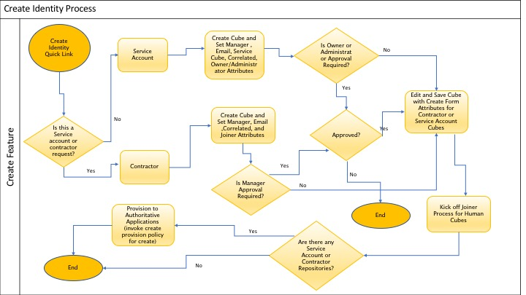

## Edit Identity Process

This process starts from a “Edit Identity” QuickLink. The “Accelerator Pack Edit Identity” form can be extended with customer specific fields for human/non-human cubes.

By default, the attribute synchronization process gets kicked off for human cubes after cube changes.

By default, cube changes are provisioned to authoritative applications that are used for Service Accounts or Non-Employee. Here are the pre-requisites for provisioning:

* Authoritative applications must have either of the attributes set either via the Administrative Wizard or the Self-Service Onboarding Wizard
  + authoritativeNonEmployee
  + authoritativeServiceAccount
* PROVISIONING must be set for “featureString”
* Update Provisioning Policies must be mined and set on Authoritative Applications

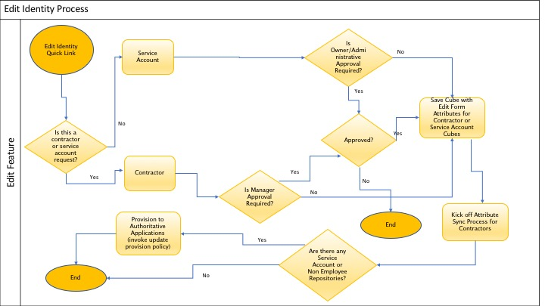

## Register Identity Process

This process starts from a “New User Registration” QuickLink. The “Accelerator Pack Registration Identity” form can be extended with customer specific fields for human cubes. A unique ID algorithm must be implemented by extending the rule “Rule-FrameWork-Registration-Generate-Unique-Id”.

By default, the joiner attribute “needsJoiner” is set to “NEEDS PROCESSING” to ensure that the joiner process gets kicked off for human cubes.

## Approvals

By Deafult, two levels of approvals are packaged with Accelerator Pack for Create, Edit, and Register Identity.

* Manager or Service Account Owner or Admin Approval
* Workgroup Approval

These approvals can be configured using Global Definitions QuickLink for Workgroup Name and reducing two level of approvals to either one or none for each request type.

